
RAMAIAH
Institute of Technology
USN | 1 | M | S

(Autonomous Institute, Affiliated to VTU)
(Approved by AICTE, New Delhi & Govt. of Karnataka) Accredited by NBA & NAAC with ‘A’ Grade

EXAMINATIONS SEPTEMBER /OCTOBER 2020
SUPPLEMENTARY SEMESTER / GRADE IMPROVEMENT/ RE –REGISTERED CANDIDATES
Program | : | B.E. : Common to CSE/ISE | Semester | : | IV
Course Name | : | Engineering Mathematics - IV | Max. Marks | : | 100
Course Code | : | CS/IS41/MAT41 | Duration | : | 3 Hrs

Instructions to the Candidates:
- Answer any one full question from each unit.

 |  | UNIT- I
1. | a) | Define interpolation and extrapolation. | CO1 | (02)
1. | b) | Construct the forward difference table of the function 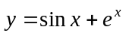 over the interval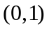with step length 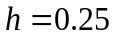 and hence write the value of 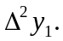 | CO1 | (04)
1. | c) | Fit an interpolating polynomial for the following data using Newton’s divided difference formula and hence find the values of 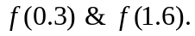 | CO1 | (07)
   | -1 | 0 | 2 | 3
  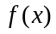 | -8 | 3 | 1 | 12
1. | d) | Using Simpson’s 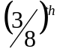rule obtain the approximate value of 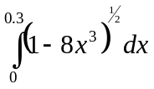 by considering 7 ordinates. | CO1 | (07)
2. | a) | Define forward and backward difference operator. | CO1 | (02)
2. | b) | Evaluate 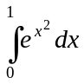 using trapezoidal rule considering four sub intervals. | CO1 | (04)
 | c) | A slider in a machine moves along a fixed straight rod. Its distance cm along the rod is given below for various value of the time sec. Find the velocity of the slider and its acceleration when = 0.5 sec. | CO1 | (07)
   | 0 | 0.1 | 0.2 | 0.3 | 0.4 | 0.5
   | 30.13 | 31.62 | 32.87 | 33.64 | 33.95 | 33.81
 | d) | Use Lagrange’s interpolation formula to find 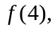 given: | CO1 | (07)
   | 0 | 2 | 3 | 6
  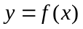 | -4 | 2 | 14 | 158
 |  | UNIT- II
3. | a) | In a Binomial distribution mean and variance are and 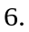Find number of trials. | CO2 | (02)
 | b) | A random variable X has the following probability function  Find i) K ii ) E (X). | CO2 | (04)
  X: | 1 | 2 | 3 | 4 | 5 | 6 | 7
  P(x): | K | 2K | 2K | 3K | K² | 2K² | 7K²+K
 | c) | The increase in sales per day in a shop is exponentially distributed with mean Rs.600. The sales tax is to be levied at the rate of 9%. What is the probability that the sales tax will exceed Rs.81 per day? | CO2 | (07)
 | d) | Find the mean and the standard deviation of the normal distribution of marks in an examination where 44% of candidates obtained marks below 55 and 6% got above 80. | CO2 | (07)
4. | a) | Write the PDF of Poisson’s distribution. | CO2 | (02)
 | b) | If a random variable is uniformly distributed over the interval (0,5). What is the probability that the roots of the equation 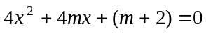 are real. | CO2 | (04)
 | c) | The PDF of a random variable X is given by 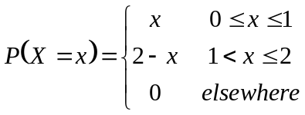 Find  - Cumulative distribution function ii) 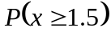 | CO2 | (07)
 | d) | The daily consumption of milk in excess of 35,000 liters is a Gamma variate with 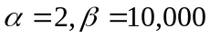. The town has a daily stock of 40,000 liters. Find the probability that the stock is adequate on a randomly selected day. If 100 consecutive days are considered what is the probability that stock is adequate at least for two days. | CO2 | (07)
 |  | UNIT- III
5. | a) | Define stationary process. | CO3 | (02)
 | b) | The joint probability mass function of 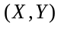is given by:  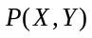= 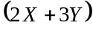, = 0,1,2; =1,2,3. Find the joint probability distribution ofand. | CO3 | (04)
 | c) | A random process 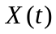 is described by the ensemble 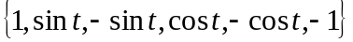. Show that is WSS but not SSS. | CO3 | (07)
 | d) | Suppose that the joint density function of two continuous random variables and is 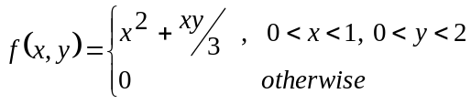, Find (i) 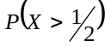 (ii) 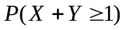 | CO3 | (07)
6. | a) | Define marginal probability distribution of X and Y. | CO3 | (02)
 | b) | A random process X(t) is represented by the ensemble  {-k, -2k, -3k, k, 2k, 3k}, (k > 0) corresponding to the outcomes of an event which are equally probable. Verify whether the random process is SSS or WSS. | CO3 | (04)
 | c) | A fair coin is tossed three times. Let X denote 0 or 1 according as the head or tail occurs on the first toss. Let Y denote the number of heads which occur i) Find the marginal distributions of X and Y ii) determine the Joint distribution of X and Y and iii) COV (X,Y). | CO3 | (07)
 | d) | Find the auto correlation 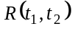 of the stochastic process defined by 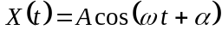, where the random variables and are independent and is uniform in the interval 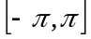. | CO3 | (07)
 |  | UNIT- IV
7. | a) | Define regular stochastic matrix. | CO4 | (02)
 | b) | Automatic car wash facility operates with only one boy. Car arrives according to a Poisson distribution, with a mean of 4 cars per hour and may wait in the facility’s parking lot if the boy is busy. If the service time for all cars is constant and equal to 10 minutes determine E(m), E(n). | CO4 | (04)
 | c) | A salesman’s territory consists of three cities A,B,C. He never sells in the same city on successive days. If he sells in city A, then the next day he sells in city B. However, if he sells in either B or C, the next day he is twice as likely to sell in city A as in other city. In the long run how often does he sell in each of the cities? | CO4 | (07)
 | d) | In a heavy machine shop, the overhead crane is 75% utilized. Time study observations gave the average service time as 10.5 mins. With a standard deviation 8.8mm. What is the average calling rate for the services of the crane and what is the average delay in getting service? If the average service time is cut to 8 min, with standard deviation of 6 min how much reduction will occur, an average in the day delay of getting served. | CO4 | (07)
8. | a) | Define M/M/1 and M/G/1 queuing models. | CO4 | (02)
 | b) | Trains arrive at the yard every 15 minutes and the service time is 33 minutes. If the line capacity of the yard is limited to 5 trains, find the probability that the yard is empty and the average number of trains in the system. | CO4 | (04)
 | c) | A telephone exchange receives one call for every 4 minutes and connects one call for every 3 minutes. If the rate of arrival follows Poisson distribution and service time follows exponential distribution find (i) Expected waiting time for a call (ii) Expected time in the system (iii) Expected number of customers in the system. | CO4 | (07)
 | d) | In a railway marshalling yard goods trains arrive at the rate of 30 trains per day. Assuming that the inter-arrival time follows exponential distribution and the service time distribution is also exponential with an average of 36 minutes. Find (i)Expected queue size (ii) probability that the queue size exceeds 10. | CO4 | (07)
 |  | UNIT- V
9. | a) | Define testing of hypothesis. | CO5 | (02)
 | b) | Test the equality of standard deviations for the data given below at 5% level of significance : 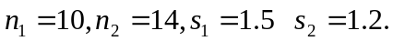 | CO5 | (04)
 | c) | A group of 10 rats fed on a diet A and another group of 8 rats fed on a different diet B recorded the following increase in weights in gms.  Test whether the diet A is superior to diet B. | CO5 | (07)
  Diet A | 5 | 6 | 8 | 1 | 12 | 4 | 3 | 9 | 6 | 10
  Diet B | 2 | 3 | 6 | 8 | 1 | 10 | 2 | 8 | - | -
 | d) | Fit a Poisson distribution for the following data and test the goodness of fit. | CO5 | (07)
  x: | 0 | 1 | 2 | 3 | 4 | 5 | 6 | Total
  f: | 273 | 70 | 30 | 7 | 7 | 2 | 1 | 390
10. | a) | Define null hypothesis and alternate hypothesis. | CO5 | (02)
 | b) | A sample of 12 measurements of the diameter of a metal ball gave the mean 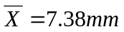with standard deviation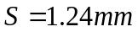. Find 95% confidence limits for the actual diameter. | CO5 | (04)
 | c) | The theory predicts that the proportion of beans available in four groups A,B,C,D should be 9:3:3:1. In an experiment with 1600 beans the numbers in the four groups were 882, 313, 287 and 118. Use  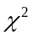- test to verify whether the experimental result supports the theory. | CO5 | (07)
 | d) | Nine patients to whom a certain drug was administrated and registered the following increments in blood pressure; 7, 3, -1, 4, -3, 5, 6, -4, 1. Do the data indicate that the drug was responsible for these increments? | CO5 | (07)
****************

